MASONRY
CON/OS/MSN/02/4/MA

PERFORM MASONRY WORK FINISHES
MAY-JULY 2025

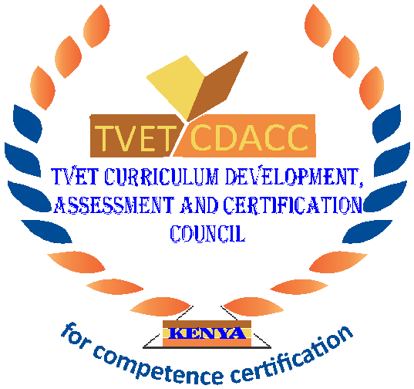
TVET CURRICULUM DEVELOPMENT, ASSESSMENT AND CERTIFICATION COUNCIL (TVET CDACC)

PRACTICAL ASSESSMENT

INSTRUCTIONS TO THE ASSESSOR:
- This assessment is to take place in the prescribed order as arranged in the tool.
- Capture clear photographs and/or videos of each candidate’s work at critical points as they perform the tasks and label all media files with: Candidate Registration Number, Unit Code, Practical Session Number, and Date.
- Record candidate scores and assessor remarks in the observation checklists for each session.
Store all completed checklists, media files, and candidate drawings in a secure digital/physical folder per candidate
- CANDIDATE & ASSESSOR DETAILS
Candidate Name: | CDACC Reg. No.:
Assessor Name: | Assessor ID Number:

- PROJECT BRIEF
In this project, the candidate will be required to demonstrate competence in all three elements by completing three hands-on sessions (each ~4 hours) and an oral assessment (~1 hour). Follow the working drawings and specifications provided.

- SECTION 1 (SESSION 1: 4 HOURS): WALL PLASTERING
Assessment Date:
Assessment Venue:

Elements Covered:
- Carry out wall plastering
Task
The candidate should:
- Construct a 3-course masonry wall in stretcher bond of length 1500mm.
- Apply 20mm plaster to one face of the wall using a 1:3 lime-sand mix.
- Provide a 100mm mortar skirting on the plastered face (25mm).

PRACTICAL CHECKLIST
No. | Items to Evaluate | Max marks | Marks Awarded
 | Wore PPEs  - Overall  - Gloves  - Safety Boots  - Safety Helmet  (Award 1 for each PPE worn) | 4
 | Assembled all the required tools.  - Tape measure  - Trowel  - Shovel  - Wood float  - Spirit level  - Plumb bob  - Straight edge  - Masons hammer  (Award 1mark x 6 for correctly assembled) | 8
 | Assembled all the required Materials.  - Block  - Lime  - Sand  (Award 1 marks for the assembled materials) | 3
 | Mixed the mortar for plastering  (Award marks for ratio used in mixing and 1 mark for the correct mixing procedure) | 2
 | Preparation of the wall to receive plastering  - Hacking  - Removal of dust particles  - Wetting the surface  (Award 1 mark for each procedure) | 3
 | Plastered the wall  - Roughing of the surface  - Alignment of the surface  - Final finishing of the surface  (Award 2 marks for each for each step) | 6
7. | Smooth finished surface  (Award 4 marks for smooth and evenly distributed plaster) | 4
8. | Uniform thickness of plaster.  (Award 2 marks for uniformity) | 2
9. | Plumbness of plaster.  (Award 1 mark each for any 3 places) | 3
10. | Appearance  (Award 2 marks for good appearance) | 3
11. | Completeness  100% - 4  75% - 3  50% - 2  Below 50% - 1 | 4
 | TOTAL | 42
NB: Photos and videos should be taken as the candidate performs items 5 and 6.

- SESSION 2 (SECTION 2: 4 HOURS): SCREEDING
Assessment Date:
Assessment Venue:

Element Covered:
- Lay floor screed
TASK
The candidate should:
- Prepare a 1m² floor surface for screed. (clean, wet)
- Lay a 50mm thick bonded screed (1m² Area)
- Level and apply a steel finish

PRACTICAL CHECKLIST
No. | Items to Evaluate | Max Marks | Awarded Marks
 | Wore PPEs  - Overall  - Gloves  - Safety Boots  - Safety Helmet  (Award 1 for each PPE worn) | 4
 | Correctly assembled tools.  - Tape measure  - Trowel  - Shovel  - Wood float  - Spirit level  - Straight edge  (Award 1mark for correctly assembled tool) | 6
 | Correctly assembled materials  - Lime  - Sand  (Award 1 mark for correctly assembled materials for the works) | 2
 | Correct mixing of screed.  (Award 3 marks for correct mixing or zero) | 3
 | Surface preparation to receive the screed.  (Award 3 marks for the correct procedure) | 3
 | Leveling of the screed  (Award 3 marks for the correct procedure) | 3
 | Uniform thickness of the screed  (Award 2 marks for uniform thickness or zero) | 2
 | Screed smooth finish.  (Award 3 marks for smoothness or zero) | 3
 | Proper housekeeping  (Award 3 marks if the area around the project is cleared or zero) | 3
 | Appearance  (Award 3 marks for good appearance or zero) | 3
 | Completeness.  100% - 4  75% - 3  50% - 2  Below 50% - 1 | 4
 | TOTAL | 36
NB: Photos and videos should be taken as the candidate performs items 4, 5 and 6.
- SESSION 3 (SECTION 3: 5 HOURS): KEYING AND POINTING
Assessment Date:
Assessment Venue:

Element Covered:
- Carry out wall keying and pointing
Task
The candidate should:
- Prepare mortar (1:3 mix) for pointing.
- Erect 4 courses and 1500mm long walling.
- Demonstrate keying on the walling.
- Execute recessed pointing on two lines of the courses.
PRACTICAL CHECKLIST
No. | Items to Evaluate | Max Marks | Marks Awarded
 | Wore PPEs  - Overall  - Gloves  - Safety Boots  - Safety Helmet  (Award 1 Marks for PPE for any 3 worn) | 3
 | Assembled and used all tools.  - Tape measure  - Trowel  - Shovel  - Wood float  - Spirit level  - Straight edge  (Award 1mark x 6 assembled and used = 6 Marks) | 6
 | Mixing of mortar  (Award 3 marks for well mixing or zero) | 3
 | Wall surface well prepared  (Award 3 marks for well-prepared surface or zero) | 3
 | Levelness of keyed joints  (Award 1 mark each for the 3 courses = 3 Marks0 | 3
 | Key pointing  (Award 1mark each for the 3 courses 3 Marks) | 3
 | Curing and tool cleaning observed  (Award 3 marks or zero) | 3
 | Proper housekeeping  (Award 2 marks if the area around the project is cleaned/ cleared or zero) | 2
 | Quality appearance  (Award 2 marks for good appearance or zero) | 2
 | Completeness.  100% - 4  75% - 3  50% - 2  Below 50% - 1 | 4
 | TOTAL | 32
NB: Photos and videos should be taken as the candidate performs items 3, 4 and 5.
- SECTION 4 – ORAL ASSESSMENT (25 MARKS)
Assessor to Award marks for each correct response by the candidate in the table below:
No | Question | Expected Answer | Max Marks | Awarded
1 | Why is plumbness important in wall plastering? | Ensures vertical alignment, aesthetic finish | 3
2 | What PPE is necessary when applying screed? | Helmet, gloves, goggles, boots | 3
3 | State two types of screeds. | Bonded, unbonded, floating | 3
4 | Why should wall surfaces be dampened before rendering? | Prevent moisture loss from render | 3
5 | What tools are used in pointing? | Pointing trowel, jointing tools | 3
6 | How do you ensure even plaster thickness? | Use dot guides and straight edge | 3
7 | What curing method is used for plaster? | Water spray, damp hessian, plastic sheet | 3
8 | Name one defect caused by improper plaster application. | Cracks, peeling, uneven surface | 4
 | TOTAL: |  | 25

SUMMARY OF ASSESSMENT
Section | Max Marks | Marks Awarded
Assessment 1 | 42
Assessment 2 | 36
Assessment 3 | 32
Total | 110
Percentage (%)
ORAL ASSESSMENT
Oral (Section 4) | 25
Percentage (%)

The candidate was found to be:

Competent Not yet Competent
(Please tick as appropriate)
The candidate is competent if the candidate obtains at least 50%

