MASONRY
CON/OS/MSN/CR/03/4/MA
PRODUCE MASONRY UNITS.
MAY-JULY 2025
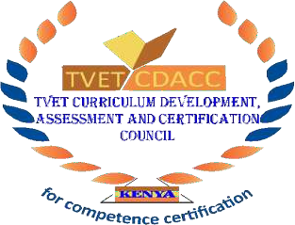
TVET CURRICULUM DEVELOPMENT, ASSESSMENT AND CERTIFICATION COUNCIL (TVET CDACC)

PRACTICAL ASSESSMENT

INSTRUCTIONS TO THE ASSESSOR
- This assessment is to take place in the prescribed order as arranged in the tool.
- Capture clear photographs and/or videos of each candidate’s work at critical points as they perform the tasks and label all media files with: Candidate Registration Number, Unit Code, Practical Session Number, and Date.
- Record candidate scores and assessor remarks in the observation checklists for each session.
- Store all completed checklists, media files, and candidate drawings in a secure digital/physical folder per candidate.

CANDIDATE & ASSESSOR DETAILS
Candidate Name: | CDACC Reg. No.:
Assessor Name: | Assessor ID Number:

PROJECT BRIEF
In this project, you will be required to demonstrate competence in all three elements by completing three hands-on sessions (each ~4 hours) and an oral assessment (~1 hour). Follow the working drawings and specifications provided.

SECTION 1 (SESSION 1: 4 HOURS): PRODUCE CLAY BRICKS
Assessment Date:
Assessment Venue:

Elements Covered:
- Produce Clay Masonry Units
Tasks
The candidate should:
  - Prepare a wooden brick mould. (Size 215mm x 102.5mm x 65mm
  - Weathering and tampering of clay
  - Prepare Four clay bricks (Size 215mm x 102.5mm x 65mm).

PRACTICAL CHECKLIST
No. | Items to be Evaluated: | Marks Available | Marks Obtained
 | Wore PPEs  - Overall/dust coat  - Safety boots  - Helmet  - Gloves  (Award 1 mark for each PPE worn as per workplace procedures) | 4
 | Collected all necessary tools  - Spade  - Wooden mould  - Claw Hammer  - Hoe  - Trowel  - Sieve  - Try Square  - Hand Saw  (Award 5 marks for each tool correctly selected) | 8
 | Assembled all necessary materials  - Clay soil  - Water  - Plastic sheets  - 150mm x 25mm timber  (Award 1 mark for each correctly selected material) | 3
 | Prepare the brick mould.  - Measuring  - Cutting  - Joining  (Award 3 marks for correct procedure) | 3
 | Mould constructed to the correct size  (Award 1 mark for each side or zero) | 4
 | Firm mould joints.  (Award 1 mark for each joint or zero) | 4
 | Mould squareness.  (Award 2 mark for each corner or zero) | 4
 | Batched and mixed the concrete ingredients.  - Sieving  - Batching  - Mixing  (Award 3 marks for correct procedure) | 3
 | Placed the brick mould in appropriate position.  (Award 2 marks for correct procedure) | 2
 | Pour clay ingredients into the brick mould, compact and level.  (Award 1 mark for each correct procedure) | 3
 | Demoulded the mould  (Award 2 marks for correct procedure) | 2
 | Squared brick corners.  (Award 1 mark for each corner or zero) | 4
 | Levelled brick top.  (Award 1 mark for each or zero) | 4
 | Brick well compacted  (Award 1 mark for each or zero) | 4
 | No visible honeycombs  (Award 1 marks for the six faces or zero for each) | 6
 | Smooth surface on the sides and the top.  (Award 1 mark for each of the five sides or zero) | 4
 | - Completion:  - 100% - 3  - 70% - 2  - 50% - 1 | 3
 | TOTAL | 65
NB: Photos and videos should be taken as the candidate performs items 4, 8, 10 and 11.

SECTION 2: (SESSION 2: 4 HOURS): PRODUCE CONCRETE & STABILIZED SOIL BLOCKS
Assessment Date:
Assessment Venue:

Elements covered
- Produce Concrete Masonry Products
- Produce Stabilized Soil Masonry Units
Tasks:
The candidate is expected to:
- Prepare wooden concrete mould (400 x 200 x 225 mm).
- Prepare four concrete blocks (400 x 200 x 225 mm).
- Mix stabilized soil and prepare 3 soil blocks (400 x 200 x 225 mm).

PRACTICAL CHECKLIST
No. | Items to be Evaluated: | Marks Available | Marks Obtained
 | Wore PPEs  - Overall/dust coat  - Safety boots  - Helmet  - Gloves  (Award one mark for each PPE worn as per work place procedures) | 4
 | Collected all necessary tools  - Spade  - Claw Hammer  - Straight edge  - Hoe  - Trowel  - Wheelbarrow  (Award 3 marks for any 3 correctly selected tool) | 3
 | Assembled all necessary materials  - Quarry dust  - Water  - cement  - Sand  - Plastic sheets  - 150mm x 25mm timber  - Nails  (Award 4 marks for any 4-material collected) | 4
 | Prepare the concrete mould.  - Measuring  - Cutting  - Joining  (Award 1 mark for each correct procedure) | 3
 | Mould constructed to the correct size  (Award 1 mark for each side or zero) | 4
 | Firm mould joints.  (Award 1 mark for each joint or zero) | 4
 | Mould squareness.  (Award 2 mark for each corner or zero) | 8
 | Batched and mixed the concrete ingredients.  (Award 3 marks for correct procedure) | 3
 | Oil and place the brick mould in an appropriate position.  (Award 2 marks for correct procedure) | 2
 | Poured concrete ingredients into the block mould, compact and level.  (Award 2 mark each for correct procedure) | 2
 | Demoulded the mould  (Award 2 marks for correct procedure) | 2
 | Squared block corners.  (Award 1 mark for each corner or zero) | 4
 | Levelled block top.  (Award 2 mark for each or zero) | 2
 | Block well compacted  (Award 2 mark for each or zero) | 2
 | No visible honey combs  (Award 2 marks or zero for each) | 2
 | Smooth surface on the sides  (Award 1 mark for each side or zero) | 3
 | - Completion:  - 100% - 3  - 70% - 2  - 50% - 1 | 3
 | TOTAL | 55
NB: Photos and videos should be taken as the candidate performs items 5, 8, 9, 10 and 11.

SECTION 3 (SESSION 3: 4 HOURS): STONE DRESSING
Assessment Date:
Assessment Venue:
Element Covered:
- Interpret Masonry Units’ Drawing
- Perform Stone Dressing
Tasks:
- Dress a stone to 300 x 190 x 110 mm with smooth faces.
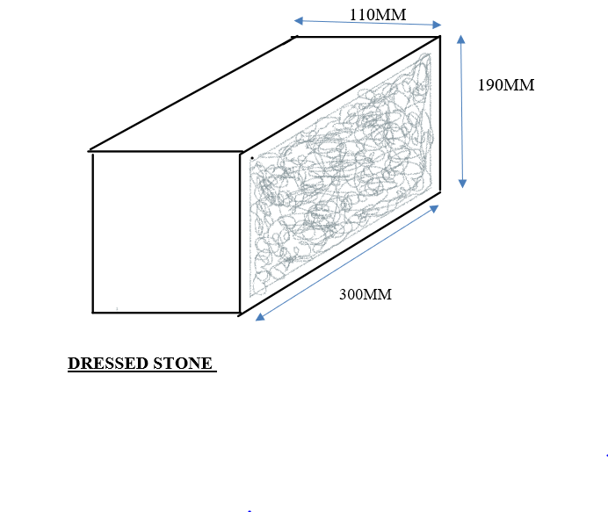
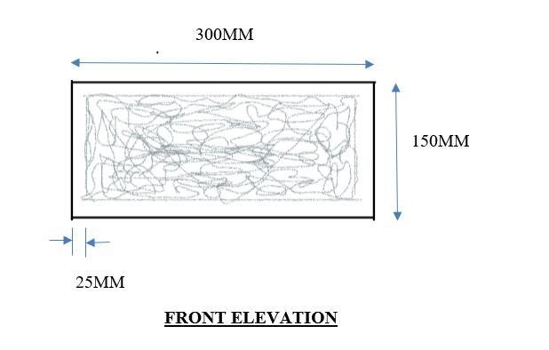
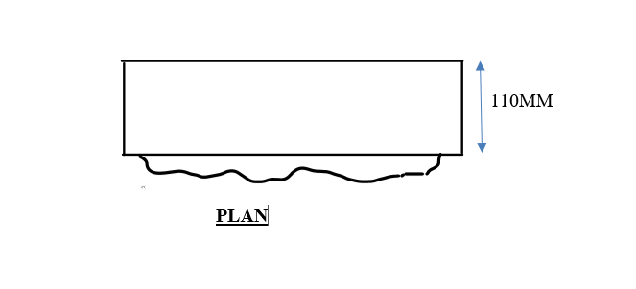
6.2. PRACTICALCHECKLIST
No. | Items to be Evaluated:  Please award marks as appropriate. Give a brief comment on your observation. | Marks Available | Marks Obtained
 | Wore PPEs  - Overall/dust coat  - Safety boots  - Helmet  - Gloves  (Award one mark for each PPE worn as per work place procedures) | 4
 | Collected all necessary tools  - Cold chisel  - Club hammer  - Masons square  - Tape measure  - Steel rule  (Award 1 marks for each correctly collected tools) | 5
 | Assembled all necessary materials  - Quary stone  (Award 1 marks for each material) | 1
 | Accurate shaping and cutting  (Award 3 marks for each correct procedure) | 6
 | Correct squareness.  (Award 6 marks for correct procedure) | 6
 | Flatness by diagonal  (Award 4 marks for correct diagonal) | 4
 | Smooth surface  (Award 1 mark for each smooth surface) | 4
 | Straightness  (Award 1 mark for each side or zero) | 8
 | Appearance or quality of workmanship  (Award 3 mark or zero) | 4
 | Completion:  - 100% -3  - 70% -2  - 50% -1 | 3
 | TOTAL | 45
NB: Photos and videos should be taken as the candidate performs item 4.
SECTION 4: ORAL ASSESSMENT (25 MARKS)
Q# | Question | Expected Answer | Max Marks | Awarded
1 | Why is tempering clay important? | Prevents cracking during drying/firing | 3
2 | Name two PPEs for concrete block production. | Gloves, goggles, dust mask (any two) | 3
3 | What is the purpose of curing blocks? | Ensures strength development | 3
4 | How do you check soil suitability for SSBs? | Roll test (non-crumbling sausage) | 3
5 | Name two stone-dressing tools. | Chisel, club hammer | 3
6 | Why stabilize soil with cement? | Improves durability and water resistance | 3
7 | What bond pattern is common in brickwork? | Stretcher bond | 2
8 | How long should concrete blocks cure? | 7–14 days | 2
 | Total | 25
SUMMARY OF ASSESSMENT
No. | Section | Total Marks | Marks Awarded
 | Assessment 1 | 65
 | Assessment 2 | 55
 | Assessment 3 | 45
 | TOTAL
Percentage (%)
ORAL ASSESSMNET
 | Oral (Section 4) | 25
Percentage (%)

The candidate was found to be:

Competent Not yet Competent
(Please tick as appropriate)
The candidate is competent if the candidate obtains at least 50%

