ELECTRICAL INSTALLATION ENG/OS/EI/CR/02/3/MA
Install Trunking System
July/August 2025
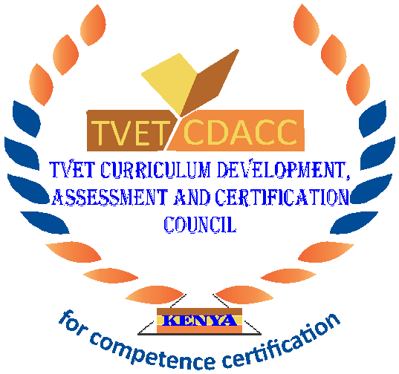
TVET CURRICULUM DEVELOPMENT, ASSESSMENT AND CERTIFICATION COUNCIL (TVET CDACC)

PRACTICAL ASSESSMENT

INSTRUCTIONS TO THE CANDIDATE:
- This unit of competence shall be assessed in three phases.
- Each assessment session has the duration included in brackets
- The third phase of the assessment shall include a practical session and an oral assessment session.
- The assessor will take photos and videos as you perform the tasks at critical points during the assessment.
- Ensure all required resources for the assessment have been provided before beginning the
- assessment.
- All measurements are in millimeters (mm)

      - PRACTICAL ASSESSMENT 1 (4 HOURS)
Element covered
Identify trunking Accessories
TASKS
- Identify trunk types and sizes from a variety provided by the assessor
- Identify various conduit accessories from a variety provided by the assessor
      - PRACTICAL ASSESSMENT 2 (4 HOURS)
Elements covered
- Prepare Trunking work pieces
- Mount Prepare Trunking work pieces
TASK
- Prepare both metallic trunking work pieces for the installation of Figure 1
- Mount metallic trunking work pieces for the installation of Figure 1
- Figure 1 shows an electrical layout diagram of a final sub-circuit.
- Draw the wiring diagram
- Install the circuit such that lamp L1 is controlled by switch S1
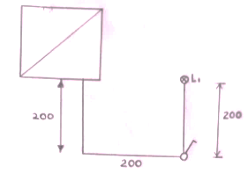
Figure 1
      - PRACTICAL ASSESSMENT 3 (4 HOURS)
Element covered
- Mount Trunking work pieces
- Install of electrical cables and accessories
- Perform Tests and Inspection
TASK
- Figure 2 shows a layout diagram of final sub-circuits. Draw a wiring diagram such that:
- Lamp L1 and L2 are controlled from two different points
- socket outlets are connected in radial
- Using PVC trunking system, install the circuit in Figure 2
- Perform the following tests
- Continuity
- Polarity
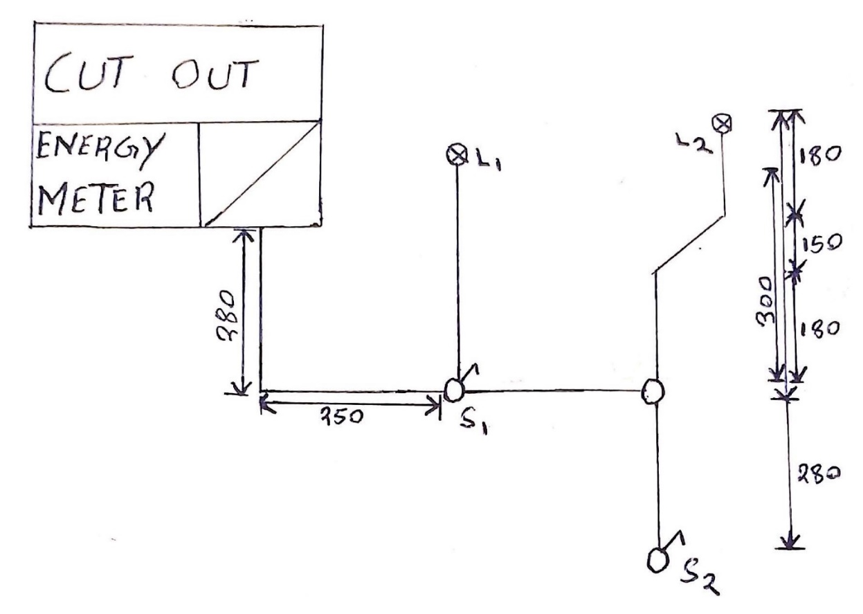
Figure 2

