MASONRY
CON/OS/MSN/CR/03/4/MA
PRODUCE MASONRY UNITS.
MAY-JULY 2025

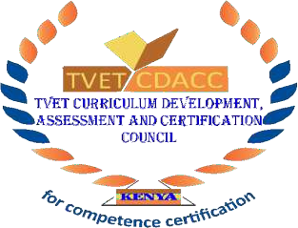
TVET CURRICULUM DEVELOPMENT, ASSESSMENT AND CERTIFICATION COUNCIL (TVET CDACC)

PRACTICAL ASSESSMENT

INSTRUCTIONS TO THE CANDIDATE:
- This unit of competence shall be assessed in three phases.
- Each assessment session has the duration included in brackets
- The third phase of the assessment shall include a practical session and an oral assessment session.
- The assessor will take photos and videos as you perform the tasks at critical points during the assessment.
- Ensure all required resources for the assessment have been provided before beginning the assessment.

SECTION 1 (SESSION 1 – 4 HOURS): PRODUCE CLAY BRICKS
Elements Covered:
- Produce Clay Masonry Units
Task
  - Prepare a wooden brick mould. (Size 215mm x 102.5mm x 65mm
  - Weather and tamper the clay
  - Prepare Four clay bricks (Size 215mm x 102.5mm x 65mm).

SECTION 2: (SESSION 2 – 4 HOURS): PRODUCE CONCRETE & STABILIZED SOIL BLOCKS
Elements Covered:
- Produce Concrete Masonry Products
- Produce Stabilized Soil Masonry Units
Tasks:
- Prepare wooden concrete mould (400 x 200 x 225 mm).
- Prepare four concrete blocks (400 x 200 x 225 mm).
- Mix stabilized soil and prepare 3 soil blocks (400 x 200 x 225 mm).

SECTION 3 (SESSION 3 – 4 HOURS): STONE DRESSING
Element Covered:
- Interpret Masonry Units’ Drawings
- Perform Stone Dressing
Tasks:
- Dress a stone to 300 x 190 x 110 mm with smooth faces.
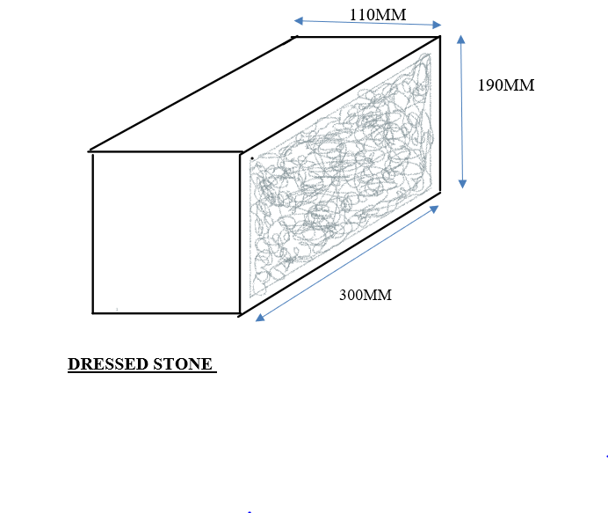
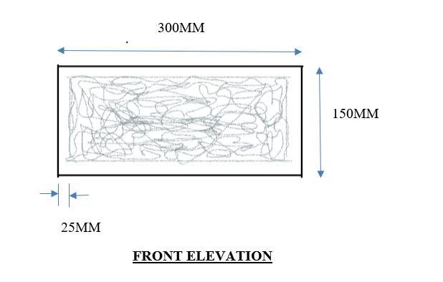
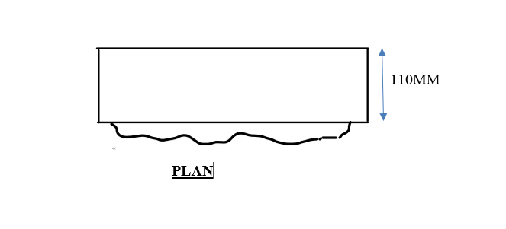
SECTION 4: The assessor will proceed to ask you oral questions for 1 hour.

