MASONRY
CON/OS/MSN/02/4/MA

PERFORM MASONRY WORK FINISHES
MAY-JULY 2025

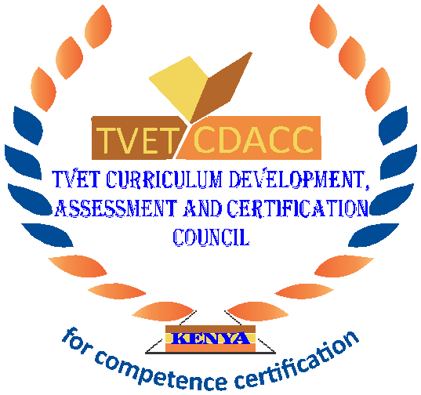
TVET CURRICULUM DEVELOPMENT, ASSESSMENT AND CERTIFICATION COUNCIL (TVET CDACC)

PRACTICAL ASSESSMENT

INSTRUCTIONS TO THE CANDIDATE:
- This unit of competence shall be assessed in three phases.
- Each assessment session has the duration included in brackets
- The third phase of the assessment shall include a practical session and an oral assessment session.
- The assessor will take photos and videos as you perform the tasks at critical points during the assessment.
- Ensure all required resources for the assessment have been provided before beginning the assessment.

SECTION 1 (SESSION 1: 4 HOURS): WALL PLASTERING
Elements Covered:
- Carry out wall plastering
Tasks
- Construct a 3-course masonry wall in stretcher bond of length 1500mm.
- Apply 20mm plaster to one face of the wall using a 1:3 lime-sand mix.
- Provide a 100mm mortar skirting on the plastered face (25mm).

SESSION 2 (SECTION 2: 4 HOURS): SCREEDING
Element Covered:
- Lay floor screed
Tasks:
- Prepare a 1m² floor surface for screed. (clean, wet)
- Lay a 50mm thick bonded screed (1m² Area)
- Level and apply a steel finish

SESSION 3 (SECTION 3: 5 HOURS): KEYING AND POINTING
Elements Covered:
  - Carry out wall keying and pointing
Tasks
- Prepare mortar (1:3 mix) for pointing.
- Erect 4 courses and 1500mm long walling.
- Demonstrate keying on the walling.
- Execute recessed pointing on two lines of the courses.

SECTION 4: The assessor will proceed to ask you oral questions for 1 hour.

